**Instruction Manual: Setting Up Redis and RabbitMQ using Docker on Windows**

**Step 1: Installing Docker on Windows**

1. **Download Docker**:
   * Go to the [Docker Desktop for Windows](https://docs.docker.com/desktop/install/windows-install/) official website.
   * Click on "Download for Windows" and download the installer.
2. **Install Docker**:
   * Find the downloaded Docker installer on your computer.
   * Double-click it to start the installation process.
   * Follow the on-screen instructions and accept the terms and conditions.
   * For detailed Instructions, [visit here.](https://docs.docker.com/desktop/install/windows-install/)
   * Make sure you have selected **Use WSL 2 instead of Hyper-V** option on the Configuration page while installing.

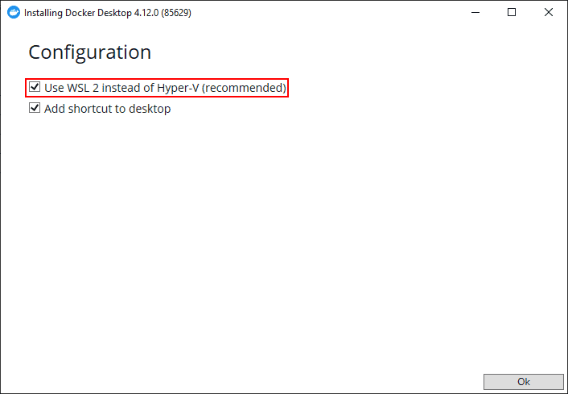

1. **Start Docker**:
   * Once installed, open Docker Desktop. It might take a few minutes to start the first time.
   * You should see a small Docker icon in your system tray, indicating Docker is running.

**Step 2: Installing Redis using Docker**

1. **Open Command Prompt**:
   * Press **Windows Key + R**, type **cmd**, and press Enter.
2. **Run Redis Docker Command**:
   * In the Command Prompt, type the following command to start a Redis instance:

*# latest Redis*

docker run -d --name redis-stack -p 6379:6379 -p 8001:8001 redis/redis-stack:latest

1. **Check Redis**:
   * After running the command, you should see a long string of numbers and letters. This means Redis is now running!
   * The Redis server is started at port 6379 and RedisInsight at 8001.

**Step 3: Installing RabbitMQ using Docker**

1. **Run RabbitMQ Docker Command**:
   * In the Command Prompt, type the following command to start a RabbitMQ instance:

*# latest RabbitMQ 3.12*

docker run -it --rm --name rabbitmq -p 5672:5672 -p 15672:15672 rabbitmq:3.12-management

1. **Check RabbitMQ**:
   * Just like with Redis, you should see a long string of numbers and letters after running the command. This indicates that RabbitMQ is running!
   * The RabbitMQ server is started at port 5672 and RabbitMQ Management at 15672.

**Note**: Always remember to stop the Redis and RabbitMQ containers when you're done using them.

**Troubleshooting:**

* **Docker Issues**: If Docker isn't starting or you're experiencing issues, try restarting Docker from the system tray icon or restart your computer.
* **Port Conflicts**: If you have other services running on ports 6379, 8001, 5672, or 15672, you may face conflicts. Ensure these ports are free before starting Redis or RabbitMQ.
* **Docker Updates**: Ensure Docker is updated to the latest version for optimal performance and compatibility.